Draft
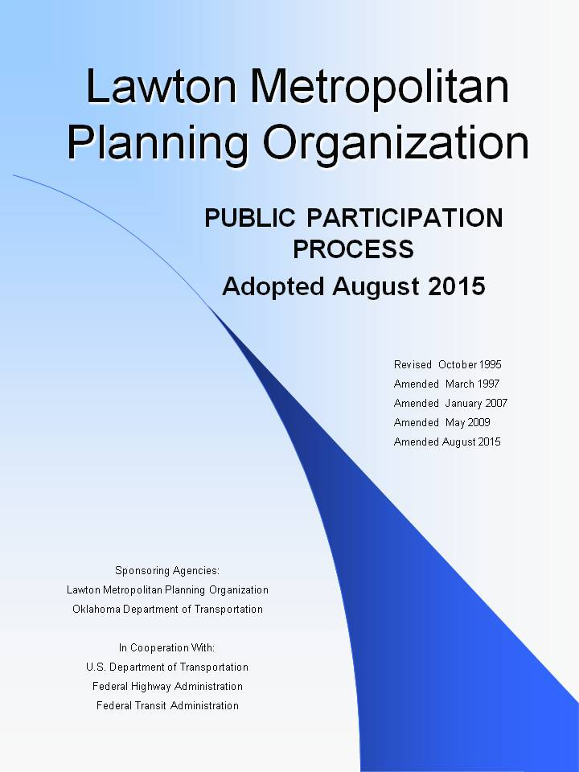

Table of Contents

Purpose of the Public Participation Plan 1
Federal Agency Requirements for Public Participation 1
The LMAT Study Area 2
Planning Documents and Public Involvement 2
1. Metropolitan Transportation Plan. 2
2. Metropolitan Transportation Plan Amendment 2
3. Transportation Improvement Program. 3
4. Transportation Improvement Program Amendment 3
5. Public Participation Plan. 3
6. Program of Projects – LATS & City Transit Trust 4
7. Annual Listing of Obligated Projects. 4
8. Unified Planning Work Program. 4
9. Other Significant Activities/Products 4
Appendix I: Table of Planning Documents and Public Involvement 5
Appendix II: List of Agencies to Receive Copies of Draft and Final Documents 8
Appendix III: Lawton Metropolitan Area Transportation Study Boundary 9
Appendix IV: Questions for Evaluation of the Public Participation Process 10

Purpose of the Public Participation Plan
This document contains the Lawton Metropolitan Planning Organization’s official policy for the provision of meaningful public participation in transportation planning and related activities. The public participation activities discussed in this document represent a comprehensive program that is intended to provide public involvement in the transportation planning process and in transportation decision making. The program established by this document is guided by federal legislation.

Federal Agency Requirements for Public Participation
The Lawton Metropolitan Planning Organization (LMPO) Public Participation Plan has been developed in accordance with the requirements of the Moving Ahead for Progress in the 21st Century Act (MAP-21). This legislature maintains a strong federal emphasis on public participation [Section 23 CFR Section 450.316]. The LMPO’s public participation shall:
- Be developed by the LMPO in consultation with all interested parties and shall, at a minimum, describe explicit procedures, strategies, and desired outcomes for:
  - Providing adequate public notice of public participation activities and time for public review and comment at key decision points, including but not limited to a reasonable opportunity to comment on the proposed metropolitan transportation plan and the Transportation Improvement Program (TIP);
  - Providing timely notice and reasonable access to information about transportation issues and processes.
  - Employing visualization techniques to describe metropolitan transportation plans and TIPs.
  - Making public information (technical information and meeting notices) available in electronically accessible formats and means, such as the World Wide Web.
  - Holding any public meetings at convenient and accessible locations and times.
  - Demonstrating explicit consideration and response to public input received during the development of the metropolitan transportation plan and the TIP.
  - Seeking out and considering the needs of those traditionally underserved by existing transportation systems, such as low-income and minority households, who may face challenges accessing employment and other services.
  - Providing an additional opportunity for public comment, if the final Metropolitan Transportation Plan (MTP) or TIP differs significantly from the version that was made available for public comment by the LMPO and raises new material issues which interested parties could not reasonably have foreseen from the public involvement efforts.
  - Coordinating with the statewide transportation planning public involvement and consultation processes; and
  - Periodically review the effectiveness of the procedures and strategies contained in the participation plan to ensure a full and open participation process (See Appendix IV for evaluation questions).

The LMAT Study Area

The Lawton Metropolitan Area Transportation (LMAT) Study Area is 99.01 square miles, including most of the City of Lawton and portions of Comanche County. In 2010, the LMAT Study Area consisted of 96,936 people. Appendix III shows the LMAT Study Area.

Planning Documents and Public Involvement

Opportunities for public participation and access to information by the traditionally underserved communities are key components, and the LMPO has taken the following steps to ensure the possibility for full and fair participation by potentially affected communities:
- Notification of availability of transportation planning documents for public review and comment in The Lawton Constitution, the LMPO website, press releases, and/or other media outlets.
- Distribution of transportation planning documents and information to various sites for review as identified in Appendix II.
- Participation in meetings with organizations and agencies when requested.

- Metropolitan Transportation Plan – The MTP is a long range, twenty-year (or more) transportation investment and multimodal policy document. It serves to guide the responsible use of public funds for transportation purposes.
- Draft and Adopted Document: Available on the LMPO website and the agencies listed in Appendix II.
- Public Comment Period: 30-day comment period. If comments received affect a significant change to the content of the Plan, a second public comment period will be held.
- Public comments received will be included in an appendix to the Plan.
- Transportation Technical Committee and Policy Board Meetings: Public meetings at which draft and final document will be reviewed/adopted. Policy Board adopts final plan.
- Public Hearing to solicit comments on draft plan. Public hearing notice in The Lawton Constitution 15 days prior to the meeting.
- Other Public Notification: In addition to the public hearing, meetings will be publicized by way of press releases, announcements on the LMPO website, and/or emails to public participation list.
- Metropolitan Transportation Plan Amendment
- Amendment available on the LMPO website and the agencies listed in Appendix II.
- Public Comment Period: MTP amendments will be publicized by way of press releases and public hearing notice in The Lawton Constitution and an announcement on the LMPO website 15 days prior to the meeting.
- Public comments received will be included in an appendix to the plan.
- Transportation Technical Committee and Policy Board Meetings: Public meetings at which draft and final document will be reviewed/adopted. Policy Board adopts final plan.
- Public Notification: In addition to public hearing notice, meetings will be publicized by way of press releases, announcements on the LMPO website, and/or emails to public participation list.
- Transportation Improvement Program – The TIP is a four-year plan that lists all regionally significant and federally funded projects and services in the study area. The TIP is updated annually. Projects in the TIP must be consistent with, or selected from, the MTP.
- Draft and Adopted Document: Available on the LMPO website and the agencies listed in Appendix II
- Public Comment Period: 30-day comment period. If comments received affect a significant change to the content of the TIP, a second public comment period will be held.
- Transportation Technical Committee and Policy Board Meetings: Public meetings at which draft and final document will be reviewed/adopted. Policy Board adopts final plan.
- Public Hearing to solicit comments on draft plan: Public hearing notice in The Lawton Constitution 15 days prior to the meeting.
- Public Notification: In addition to the public hearing notice, meetings will be publicized by way of press releases and/or announcements on the LMPO website.
- Transportation Improvement Program Amendment
- Amendment available on the LMPO website and the agencies listed in Appendix II.
- Public Comment Period: TIP amendments will be publicized by way of press releases, public hearing notice in The Lawton Constitution and/or an announcement on the LMPO website 15 days prior to the meeting.
- Transportation Technical Committee and Policy Board Meetings: Public meetings at which the amendment will be reviewed/adopted. Policy Board adopts final TIP.
- Public Hearing to solicit comments on draft plan: Public hearing notice in The Lawton Constitution 15 days prior to the meeting.
- Public Notification: In addition to public hearing notice, meetings will be publicized by way of press releases and/or announcements on the LMPO website.
- Public Participation Plan – The Public Participation Plan (PPP) lays out the strategies, techniques, and methods used to provide public participation in the transportation planning and programming process.
- Draft Document: Available on LMPO website and the agencies listed in Appendix II.
- Public Comment Period: 45-day comment period. If comments affect a significant change to the content of the Plan, a second public comment period will be held. Public comments received will be included in an appendix to the Plan.
- Transportation Technical Committee and Policy Board Meetings: Public meetings at which the amendment will be reviewed/adopted. Policy Board adopts final PPP.
- Legal Public Notice: Public Hearing to solicit comments. Public hearing notice in The Lawton Constitution 15 days prior to the Policy Board meeting.
- Public Notification: In addition to the public hearing notice, meetings will be publicized by way of press releases and/or announcements on the LMPO website.
- Program of Projects – LATS & City Transit Trust
- The Policy Board must receive a letter requesting comments from LATS General Manager 30 days prior to the City Transit Trust meeting. If elimination of route is proposed, the letter must be received 60 days prior to the meeting.
- Legal Public Notice: Public Hearing to solicit comments. Public hearing notice in The Lawton Constitution 30 days prior to the City Transit Trust meeting.
- Annual Listing of Obligated Projects – The Annual Listing is a list of projects that were federally obligated during the LMPO’s previous program year.
- Annual listing available on the LMPO website and agencies listed in Appendix II.
- Annual listing published in The Lawton Constitution within 90 days of the end of the LMPO fiscal year.
- A copy of the Annual listing will be provided to the TTC, TPB, and City Transit Trust.
- Unified Planning Work Program – The Unified Planning Work Program (UPWP) identifies transportation planning activities to be accomplished during the fiscal year and ensures that the planning process meets the federal requirements.
- Draft Document: Available on the LMPO website and the agencies listed in Appendix II 14 days prior to the meeting at which the UPWP will be reviewed.
- Transportation Technical Committee and Policy Board Meetings: Public meetings at which the UPWP will be reviewed/adopted. Policy Board adopts final UPWP.
- Public Notification: Meetings will be publicized by way of press releases and/or announcements on the LMPO website.
- Unified Planning Work Program Amendment
- Amendment available on the LMPO website and the agencies listed in Appendix II.
- Public Comment Period: UPWP amendments will be publicized by way of press releases, public hearing notice in The Lawton Constitution and/or an announcement on the LMPO website 14 days prior to the meeting.
- Transportation Technical Committee and Policy Board Meetings: Public meetings at which the amendment will be reviewed/adopted. Policy Board adopts final UPWP.
- Public Hearing to solicit comments on draft plan: Public hearing notice in The Lawton Constitution 14 days prior to the meeting.
- Public Notification: In addition to public hearing notice, meetings will be publicized by way of press releases and/or announcements on the LMPO website.

- Other Significant Activities/Products – The LMPO will consider and undertake appropriate outreach procedures on a case-by-case basis for other significant activities such as Corridor Studies, Bicycle and Pedestrian Plans, planning efforts, and other activities as deemed necessary.
See Appendix I for a Table of Planning Documents and Public Involvement.
When significant written and oral comments are received on the draft MTP and TIP (including the financial plans) as a result of the participation process in this section or the interagency consultation process required under the EPA transportation conformity regulations (40 CFR part 93), a summary, analysis, and report on the disposition of comments shall be made as part of the final MTP and TIP.

Appendix I: Table of Planning Documents and Public Involvement

 | Public Comment Period | Public Hearing Notice | TTC | TPC
MTP | Notice of 30 day comment period prior to the LMPO considering the Plan placed on the LMPO website and distributed to agencies in Appendix II | Legal notice to be published in The Lawton Constitution 15 days prior to the LMPO meeting. | TTC at a public meeting makes recommendation on the MTP to the TPB | TPB at a public meeting holds a public hearing to solicit comments and adopts the MTP by resolution
MTP Amendment | Notice of 15 day comment period prior to the LMPO considering the Plan placed on the LMPO website and distributed to agencies in Appendix II | Legal notice to be published in The Lawton Constitution 15 days prior to the LMPO meeting. | TTC at a public meeting makes recommendation on the Amendment to the TPB | TPB at a public meeting holds a public hearing to solicit comments and adopts the Amendment by resolution
TIP | Notice of 30-day comment period prior to the LMPO considering the TIP placed on the LMPO website and distributed to agencies in Appendix II | Legal notice to be published in The Lawton Constitution 15 days prior to the LMPO meeting | TTC at a public meeting makes recommendation on the TIP to the TPB | TPB at a public meeting holds a public hearing to solicit comments and adopts the TIP by resolution
 | Public Comment Period | Public Hearing Notice | TTC | TPB
TIP Amendment | Notice of 15 day comment period prior to the LMPO considering the TIP Amendment placed on the LMPO website and distributed to agencies in Appendix II | Legal notice to be published in The Lawton Constitution 15 days prior to the LMPO meeting. | TTC at a public meeting makes recommendation on the amendment to the TPB | TPB at a public meeting holds a public hearing to solicit comments and adopts the amendment by resolution.
PPP | Notice of 45-day comment period prior to the LMPO considering the PPP placed on the LMPO website and distributed to agencies in Appendix II, and to FHWA, and FTA | Legal notice to be published in The Lawton Constitution 15 days prior to the LMPO meeting. | TTC at a public meeting makes recommendation on the PPP to the TPB. | TPB holds a public hearing to solicit comments and adopts the PPP by resolution.
UPWP | Notice of 14-day comment period prior to the LMPO considering the Plan placed on the LMPO website and distributed to agencies in Appendix II |  | TTC at a public meeting makes recommendation on the amendment to the TPB | TPB at a public meeting holds a public hearing to solicit comments and adopts the amendment by resolution.
UPWP  Amendment | Notice of 14-day comment period prior to the LMPO considering the TIP Amendment placed on the LMPO website and distributed to agencies in Appendix II |  | TTC at a public meeting makes recommendation on the UPWP to the TPB. | TPB at a public meeting solicits comments and adopts the UPWP by resolution.
 | Public Comment Period | Public Hearing Notice | TTC | TPB
POP |  | Legal notice to be published in The Lawton Constitution 30 days prior to the City Transit Trust meeting. |  | TPB must receive letter from LATS General Manager 30 days before public hearing date (60 days in case of elimination of route) to request comments.
Annual Listing of Obligated Projects | A notice will be published in The Lawton Constitution within 90 days of the end of City of Lawton’s fiscal year. The Listing will be placed on the LMPO website and distributed to agencies in Appendix II

Appendix II: List of Agencies to Receive Copies of Draft and Final Documents

Lawton Main Library
110 SW 4th St
Lawton, OK 73501

Lawton Area Transit System Office
609 SW Bishop Rd
Lawton, OK 73501

City of Lawton Planning Division Office
212 SW 9th St
Lawton, OK 73501

City of Lawton Housing & Community Development Office
1405 SW 11th St
Lawton, OK 73501

Lawton-Fort Sill Regional Airport Manager’s Office
3401 SW 11th St
Lawton, OK 73501

Association of South-Central Oklahoma Governments Office
802 Main Street
PO Box 1647
Duncan, OK 73534-1647

Bureau of Indian Affairs, Southern Resource Center
PO Box 368
Anadarko, OK 73005

Fort Sill Public Works Department
Bldg 1950
Fort Sill, OK 73503

City of Lawton Engineering
2202 SW 3rd St
Lawton, OK 73501

Appendix III: Lawton Metropolitan Area Transportation Study Boundary

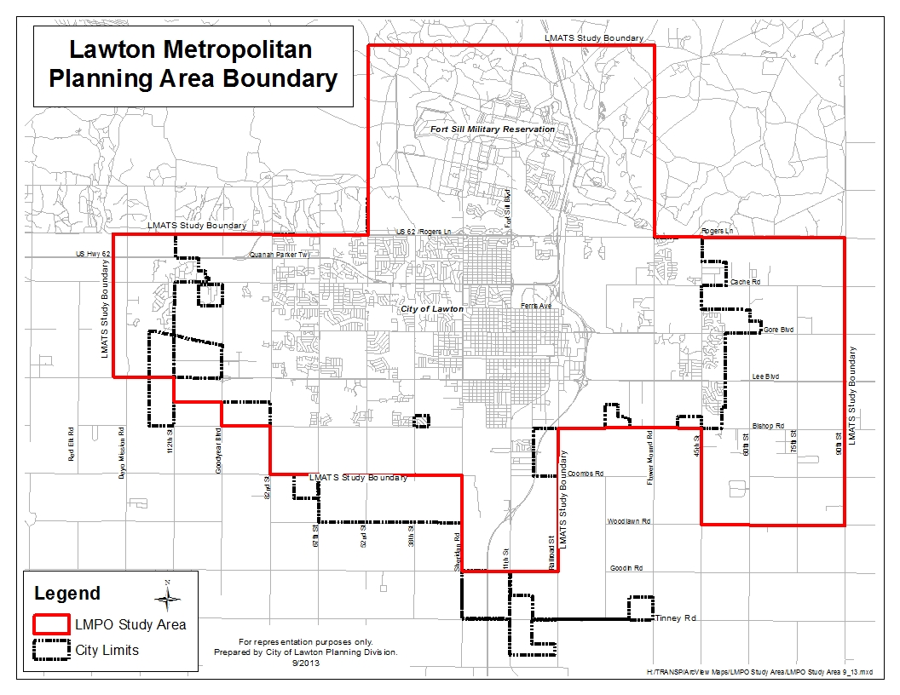
Lawton Metropolitan Planning Organization Public Participation Process

Appendix I: Lawton Metropolitan Area Transportation Study Boundary

Appendix IV: Questions for Evaluation of the Public Participation Process

1. Were all meetings held in accessible locations? Were the locations accessible by the fixed route public transportation system? Were there any complaints or requests for change related to the time or location of the public meetings?
2. Were all public meetings publicized? Were there any complaints or requests for change related to the public notice efforts?
3. Were comments received and responded to in the specified time?
4. Was the public notification mailing list updated at least annually?
5. How many documents were available on the web site?
6. How many visits did the Lawton Area Metropolitan Planning Organization Website receive?
7. If the MTP or the TIP varied significantly from the version that was initially available for public comment, was an additional public meeting held?

